**PROJECT DESIGN PHASE-II**

**Technology Stack (Architecture & Stack)**

|  |  |
| --- | --- |
| Date | 21 October 2022 |
| Team ID | PNT2022TMID24852 |
| Project Name | IOT BASED CROP PROTECTION SYSTEM |
| Maximum Marks | 4 MARKS |

**TECHNICAL ARCHITECTURE:**

The deliverable shall include the architectural diagram as below and the information as per the table 1 and table 2.

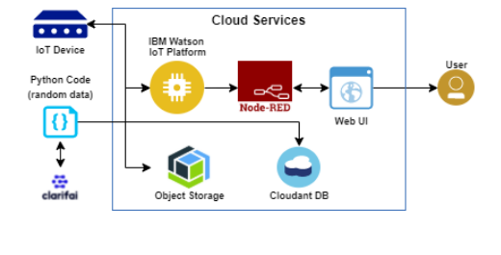

**TABLE 1: Components and Technologies**

|  |  |  |  |
| --- | --- | --- | --- |
| **S.NO** | **Component** | **Description** | **Technology** |
| **1** | User Interface | Interacts with IOT Devices | HTML, CSS, JS |
| **2** | Application Logic-1 | Logic for a process in the application | Python |
| **3** | Application Logic-2 | Logic for a process in the application | Clarify |
| **4** | Application Logic-3 | Logic for a process in the application | IBM Watson Assistant |
| **5** | Database | Data Type, Configurations etc. | MySQL, NoSQL, etc. |
| **6** | Cloud Database | Database Service on Cloud | IBM DB,IBM Cloud, etc |
| **7** | Infrastructure (Server / Cloud) | Application Deployment on Local System / Cloud Local Server Configuration: Cloud Server Configuration | Local, Cloud Foundry, Kubernetes, etc. |
| **8** | File Storage | File Storage requirements | IBM block storage or other storage service or local file system |
| **9** | External API-1 | IBM block storage or other storage service or local file system | IBM weather API etc., |
| **X** | IOT Model | Purpose of IOT Model for integrating the sensors with the user interface. I | IBM IOT platform. |

**TABLE 2:** **Application Characteristics**

|  |  |  |  |
| --- | --- | --- | --- |
| **S.NO** | **CHARACTERISTICS** | **DESCRIPTION** | **TECHNOLOGY** |
| **1** | Open-Source Frameworks | Open-source frameworks used | Python |
| **2** | Security Implementations | Authentication using encryption | Encryptions |
| **3** | Security Implementations | The scalability of architecture (3 – tier, Microservices) | Web UI Application server-python, clarify database server-IBM cloud services Technology. |
| **4** | Availability Open-source frameworks used | It is increased by Cloud and database | IBM cloud services |
| **5** | Performance | Design consideration for the performance of the application (number of requests per sec, use of Cache, use of CDN’s) etc | IBM cloud services |